
Semester Project Report


STUDENT DETAILS
Name: Muhammad.Ismail
Reg.no: SU-24-01-001-054
Semester/Program/Section: 3rd,BS CS-02
Department: CS & IT
Subject: Data Structures and Algorithms (DSA)
Date: 24-02-2026
Submitted to: Sir Mr. Niamat Ullah
PROJECT TITLE
Mini Social Network Friend Tracker
PROJECT DESCRIPTION:

Data Structures Used
Component | Data Structure | Why
Friend Profiles | Array of Structures | Easy management
Friend Connections | Graph (Adjacency Matrix) | Relationship mapping
Recent Activity | Stack | Undo functionality
Searching | Linear Search | Simple and effective
Sorting | Bubble Sort | Easy implementation

System Design Overview
We divide the system into modules:
- Profile Management
- Friendship Graph
- Activity Stack
- Search & Sort Module
- Menu System

Data Structure Design

1:Friend Structure
struct FriendProfile {
int id;
string name;
string email;
string status;
};

2:Friend Storage (Array)
FriendProfile users[50];
int userCount = 0;

3:Graph (Adjacency Matrix)
int graph[50][50]; // 1 = friends, 0 = not friends

4:Activity Stack
string activityStack[100];
int top = -1;

Core Functional Implementation
PROGRAM SCREENSHOT:

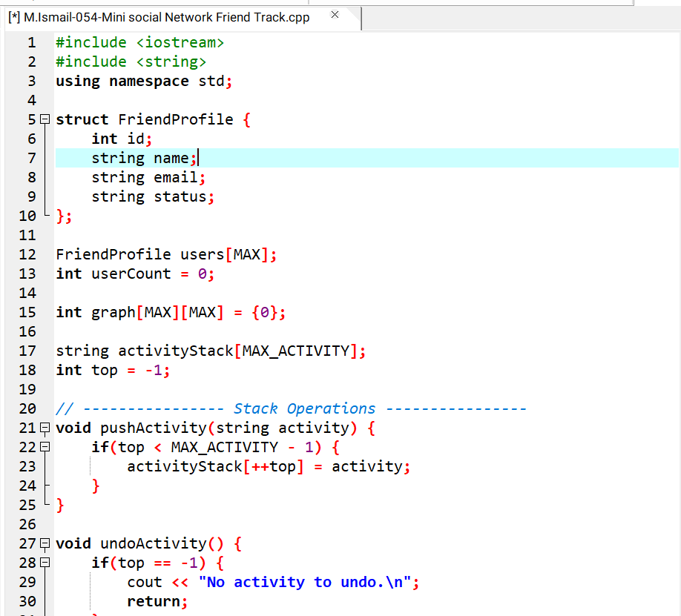

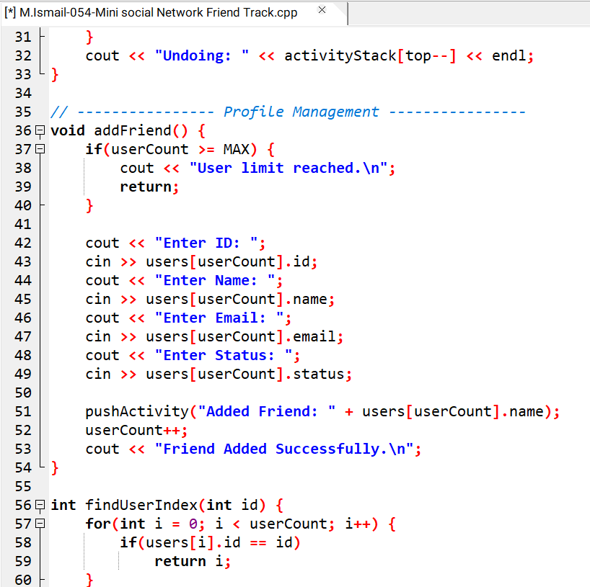
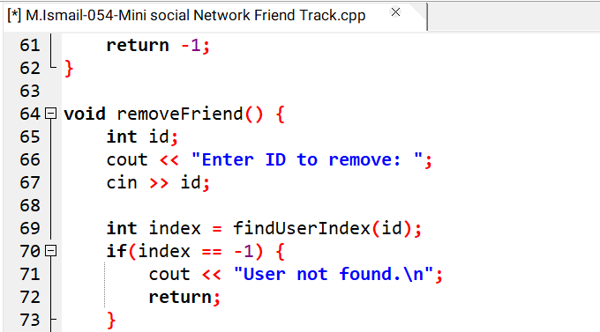
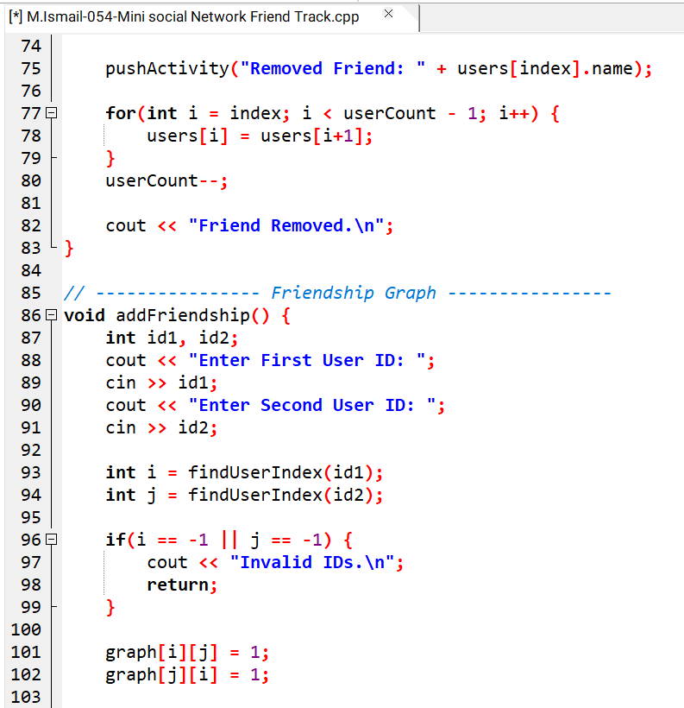
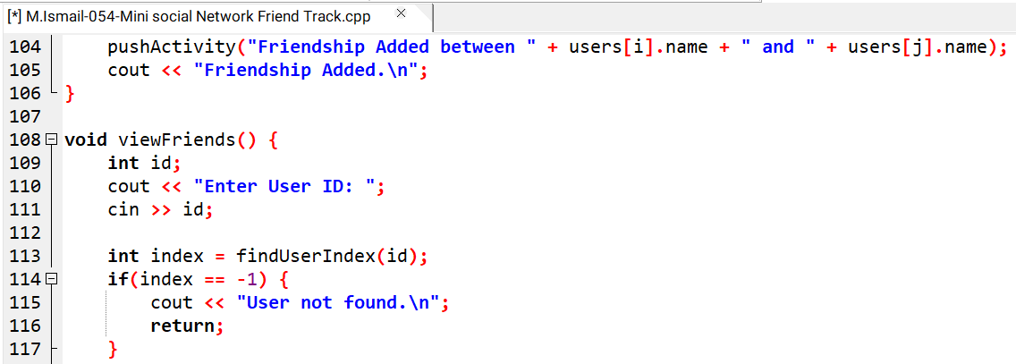
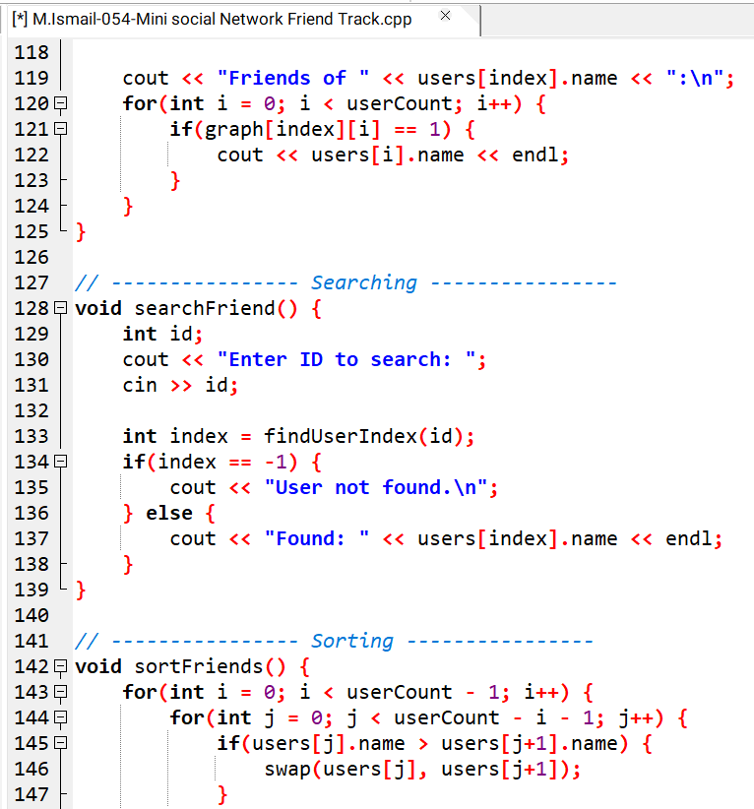
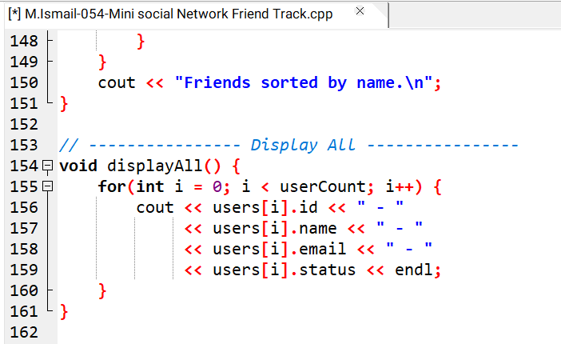
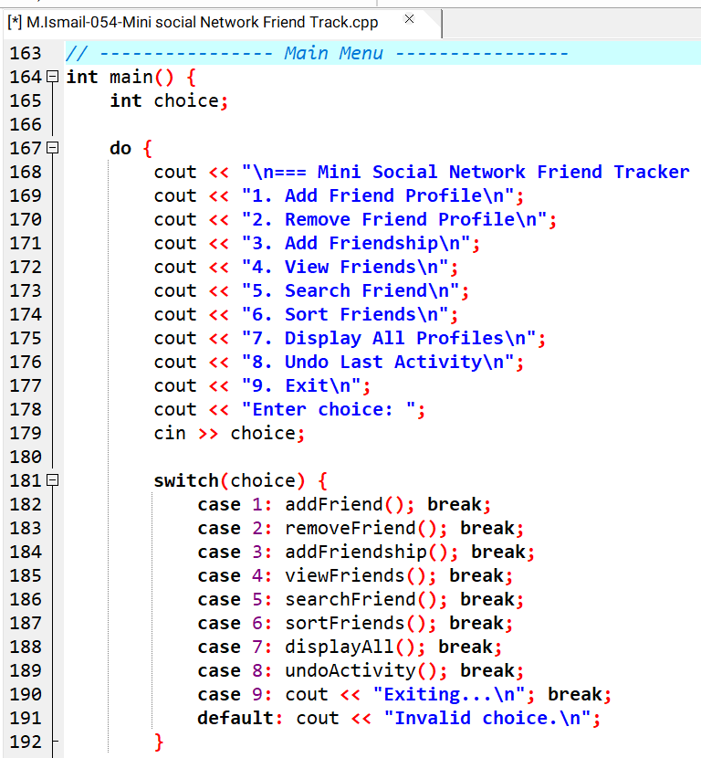
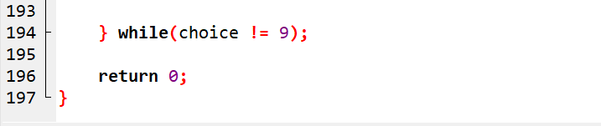

PROGRAM OUTPUT SCREENSHOT:
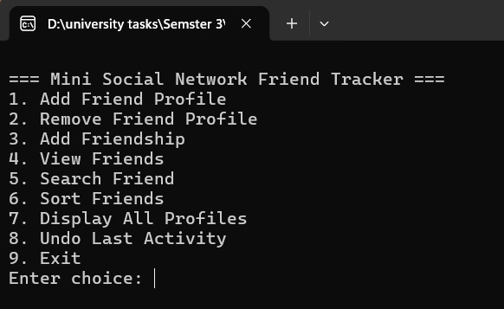
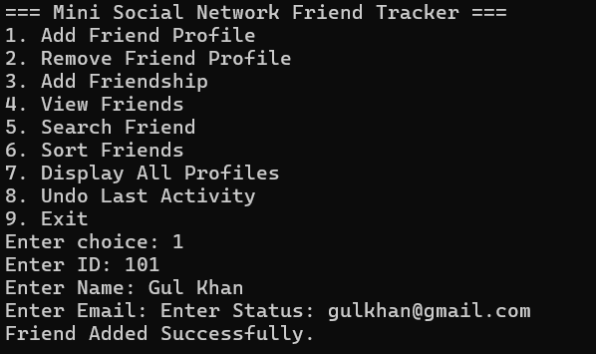
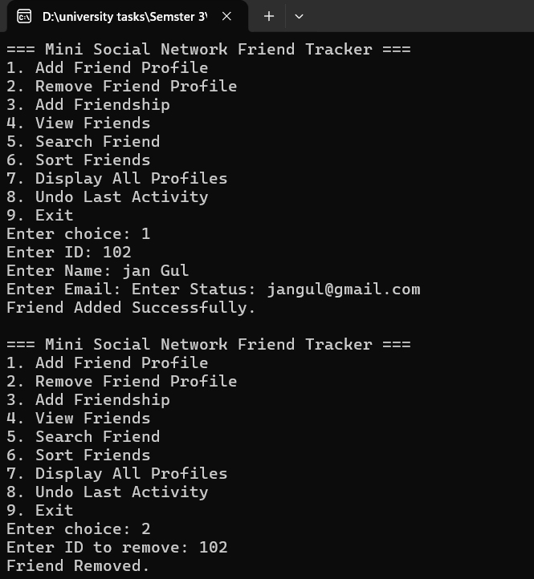
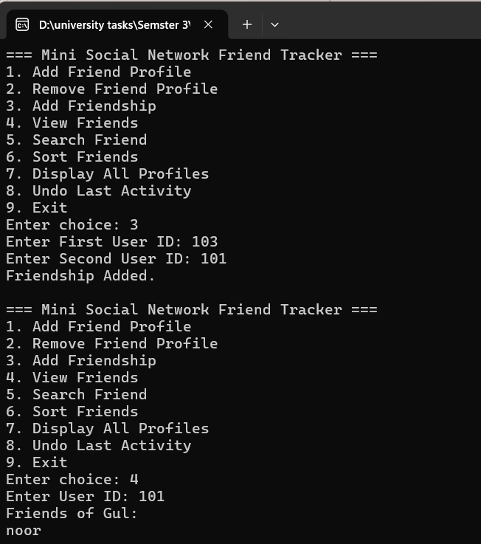
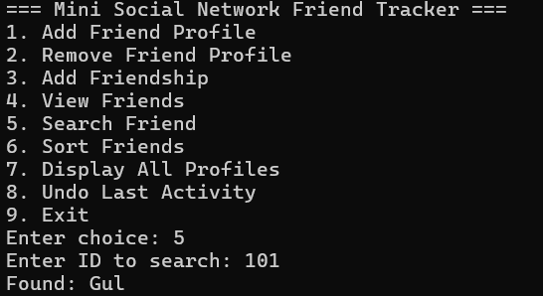
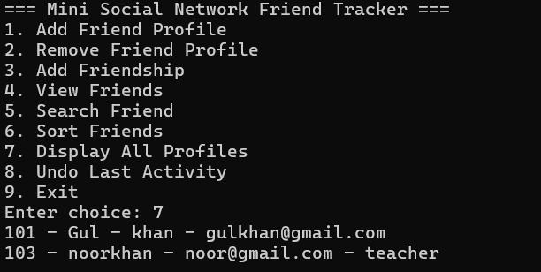
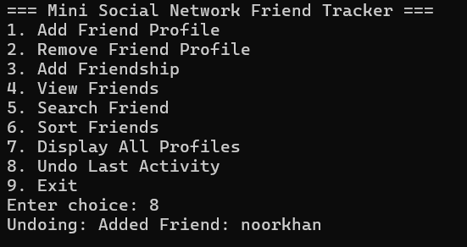
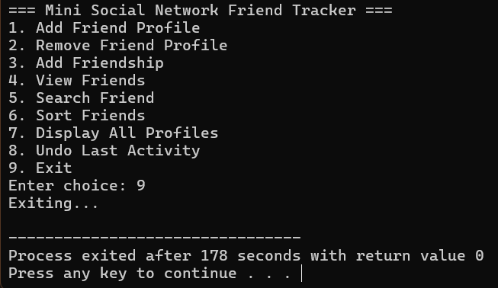

Time Complexity Analysis
Operation | Complexity
Add Profile | O(1)
Remove Profile | O(n)
Add Friendship | O(1)
Search | O(n)
Sort | O(n²)
View Friends | O(n)
Stack Push/Pop | O(1)
Space Complexity:
O(n²) for graph + O(n) for users

Instructor's Remarks

Grade:

